Multi-Zone IoT Environmental Monitoring and Control System

Electronics, Instrumentation and Communications — Complete Project Report
IoT-Enabled UVGI Air Disinfection Unit
Kunwar Laboratory
Department of Biosciences and Bioengineering
Indian Institute of Technology Bombay
Aritra Das · Roll No. 25D0074 · PhD
Supervisor: Prof. Ambarish Kunwar
Chamber design: Charudatta Khatua
Project TIH-IOT/2023-3/TDP/HA/SL-IAQ-002
Firmware baseline: Node v10.1 · Gateway v4.1 · Gateway service v1.2

Confidentiality and Disclosure Notice
Do not disclose publicly before the patent is filed
A patent application on this system has not been filed. Under Indian patent law a public disclosure before filing destroys novelty, and a public repository or an openly circulated document containing this firmware and architecture constitutes a public disclosure.
This report, and the repository it accompanies, must remain confidential until IRCC confirms an application number.

Credentials previously committed to version control
Earlier commits in the project repository contain live Wi-Fi credentials, a personal mobile number and an InfluxDB API token with read/write access. The working tree has been cleaned, but git history has not been rewritten.
The InfluxDB token must be rotated and the Wi-Fi password changed. See Section 11.

Contents
Confidentiality and Disclosure Notice 2
Contents 3
1. Executive Summary 5
1.1 What was built 5
1.2 Distinguishing characteristics 5
1.3 Honest scope of the measurements 6
2. Introduction 7
2.1 Motivation 7
2.2 Objectives 7
2.3 Scope 7
3. System Architecture 8
3.1 Overview 8
3.2 Design decisions and their justification 8
3.2.1 A dedicated microcontroller for the LoRa gateway 8
3.2.2 Two electrically isolated power rails 9
3.2.3 Hysteresis in the control law 9
3.2.4 Node-RED as the ingestion layer 9
4. Hardware 10
4.1 Sensor node bill of materials 10
4.2 Pin assignment 10
4.3 Power architecture 10
4.4 Gateway bridge 11
4.5 Enclosure 11
5. Communications 13
5.1 Channel summary 13
5.2 MQTT 13
5.3 LoRa 13
5.3.1 Radio parameters and network isolation 14
5.4 SMS 14
6. Control and Actuation 15
6.1 Command set 15
6.2 Closed-loop control law 15
6.3 Alert thresholds 15
6.4 Dual control paths 16
7. Server Infrastructure 17
7.1 Services 17
7.2 Data schema 17
7.3 Serial port preparation 17
7.4 Service automation 18
8. Firmware 19
8.1 Sensor node 19
8.1.1 Recovery 19
8.2 Gateway bridge 19
8.3 Gateway service 19
9. Multi-Zone Deployment 20
10. Verification and Current Status 21
10.1 Delivered and operational 21
10.2 Commissioning 21
10.3 Chamber context 22
11. Known Limitations and Required Work 24
11.1 Critical 24
11.2 Documentation and configuration 24
11.3 Robustness and security 25
11.4 Recommended order of work 26
12. Conclusion 27
Appendix A. Repository Contents 28
Appendix B. Service Endpoints 28

1. Executive Summary
This report documents the electronics, instrumentation and communications system developed for an IoT-enabled ultraviolet germicidal irradiation (UVGI) air disinfection unit. It covers the work end to end: hardware selection and assembly, sensor integration, firmware, three concurrent wireless channels, the server infrastructure that ingests and stores the data, the dashboards that display it, and the bidirectional control path that lets an operator actuate hardware from a browser or an SMS message.
The ultraviolet pathogen-inactivation work — bacteriophage assays, dose calculation and chamber geometry validation — is deliberately out of scope here and is documented separately. Where chamber results appear in this report, they are cited as context for design decisions, not as contributions of this work.

1.1 What was built
Subsystem | Description | Status
Sensor node | Arduino UNO R4 WiFi carrying five sensors, three radios, a relay and a PWM fan with tachometer feedback, in a transparent acrylic enclosure with dual isolated power rails | Deployed
LoRa gateway bridge | Arduino UNO R4 Minima with a second RYLR998 radio, level-shifted to Raspberry Pi GPIO | Deployed
Edge server | Raspberry Pi 5 running Mosquitto, Node-RED, InfluxDB 2.x, Grafana and Portainer under Docker | Deployed
Gateway service | Python systemd service bridging LoRa serial traffic to InfluxDB and exposing an HTTP control API | Deployed
Dashboards | 23-panel Grafana dashboard with per-zone templating and in-panel actuator controls | Deployed
Multi-zone support | Two RF-isolated models (network IDs 18 and 19) serving four zones against a shared database | Deployed

1.2 Distinguishing characteristics
Three concurrent channels, not a failover chain. Wi-Fi/MQTT carries full telemetry every five seconds, LoRa carries a compressed subset every thirty seconds, and 4G SMS carries alerts and accepts commands. All three run continuously, so the loss of any one does not interrupt monitoring or control through the other two. A failover design would have required detecting failure before switching, and detection is precisely what fails first in a dead network.
No cloud dependency. Every service except the SMS leg runs on the local network. This was a deliberate constraint: the laboratory needs monitoring to continue when campus connectivity does not.
Optical measurement of lamp output. A UV photodiode reads irradiance at the duct, which is the instrumentation needed to distinguish "the lamp was commanded on" from "the lamp is emitting" — a distinction timer-based UVGI enclosures cannot make. The sensor is fitted and reporting; the logic that would act on it is not yet written, which is treated as an open defect rather than a delivered feature. See Section 11.1.
Two independent control paths. The same dashboard button can reach a node over MQTT or over LoRa, selected at runtime by a dashboard variable, so a zone can move in and out of Wi-Fi coverage without a firmware change.

1.3 Honest scope of the measurements
Three of the reported quantities are repeatable relative signals rather than calibrated absolute measurements, and this report states that plainly rather than leaving it to be discovered later:
- The field reported as "AQI" is a linear rescale of a raw ADC count from an MQ-135 sensor. It is not an air quality index by any published definition. A calibration routine runs at first boot and its result is never used.
- UV irradiance is reported in mW/cm² but the responsivity coefficient remains a placeholder of 1.0, so the figure is a voltage relabelled.
- Fan RPM over-reads whenever the main loop stalls, because the sampling window is gated at one second but the elapsed time is never divided out. The error is spiky and correlated with cellular activity rather than a constant offset.
All three are adequate for closed-loop control and trend observation, which is what the deployed system uses them for. None is defensible in a publication or a patent specification without the work identified in Section 11.
A fourth finding, uncovered during the audit that accompanied this report, affects timing rather than accuracy: the cellular inbox poll busy-waits for a fixed five seconds on every call and is invoked every ten seconds, so a node with a working modem spends roughly half its wall-clock time inside that loop. This is the underlying cause of the fan RPM behaviour above, of publish intervals jittering between five and ten seconds, and of dashboard commands taking up to five seconds to act. It is approximately six lines to fix and is the single highest-value change available in the firmware.

2. Introduction

2.1 Motivation
Environmental monitoring in research laboratories requires continuous, reliable data across several parameters — temperature, humidity, carbon dioxide, particulate matter and gas load. Conventional approaches either rely on proprietary instruments that are expensive and inflexible, or on manual logging, which introduces transcription error and leaves gaps whenever nobody is present.
An air disinfection appliance adds a second requirement on top of monitoring: the unit must act on what it measures, and it must be possible to confirm that the action had an effect. A UVGI duct that runs on a timer provides neither guarantee. It cannot raise fan speed when the air is dirty, and it cannot tell anyone when a lamp has failed.
The system described here addresses both requirements with one instrument: a sensing and control node that monitors the air, actuates the lamp and fan according to a closed-loop rule, verifies lamp emission optically, and reports over three independent channels to a local server that stores and displays the results.

2.2 Objectives
- Instrument a UVGI air disinfection chamber with continuous multi-parameter environmental sensing.
- Provide closed-loop actuation of the UV lamp and airflow based on measured air quality, with operator override from any channel.
- Verify lamp emission optically rather than inferring it from the actuation command.
- Deliver telemetry over three independent wireless channels so that no single failure interrupts monitoring.
- Deploy a local, containerised server stack with no cloud dependency, capable of unattended operation and automatic recovery.
- Support multiple monitoring zones with radio-frequency isolation between co-located deployments.
- Produce documentation sufficient for an engineer with no prior exposure to rebuild the system from components.

2.3 Scope
In scope | Out of scope
Sensor selection, integration and calibration status | Ultraviolet pathogen inactivation efficacy
Enclosure, wiring, power architecture | Bacteriophage assay methodology and results
Firmware for sensor node and gateway bridge | Chamber fluid dynamics and dose modelling
MQTT, LoRa and SMS protocol design | Chamber mechanical design and drawings
Server stack, data pipeline and storage schema | Lamp selection and photobiological safety analysis
Dashboards and bidirectional actuator control | Patent drafting and prior art analysis
Commissioning, operations and troubleshooting

3. System Architecture

3.1 Overview
The architecture is hierarchical: sensing and actuation at the edge, a protocol-translating bridge in the middle, and a centralised server for storage and presentation. Control commands traverse the same structure in reverse.
SENSOR NODE (Arduino UNO R4 WiFi)
SCD4x · MQ-135 · GUVA-S12SD · MPM10-AS · LCD1602 · relay · PWM fan
| | |
| Wi-Fi/MQTT 5 s | LoRa 30 s, <=240 B | SMS on alert + 30 min
v v v
Mosquitto :1883 Gateway bridge (UNO R4 Minima) Operator handset
| RYLR998 + level shifter ^
v | 9600 baud UART |
Node-RED :1880 v |
| Python gateway service (systemd) |
| /dev/ttyAMA0 |
+----------+----------+ |
v |
InfluxDB 2.x :8086 internal / :8087 host |
| |
v |
Grafana :3000 ---- control buttons ----> Flask API :5000

command path (reverse):
Grafana -> HTTP -> Python -> UART -> Gateway -> LoRa -> Node
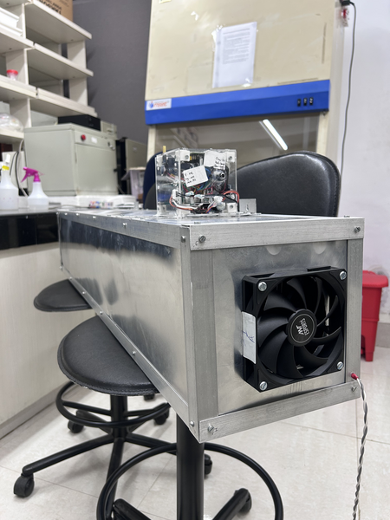
Figure 1 — The integrated appliance: polished aluminium duct on a stand, control box mounted on top near one end, 120 mm fan in the end face.

3.2 Design decisions and their justification

3.2.1 A dedicated microcontroller for the LoRa gateway
Driving the RYLR998 radio directly from Raspberry Pi GPIO was attempted and abandoned. The module is controlled by an AT-command protocol that requires deterministic response timing, and Linux is not a real-time kernel. Scheduler jitter produced dropped packets and truncated responses that were difficult to distinguish from radio-link failures.
Interposing an Arduino UNO R4 Minima resolved this. The microcontroller provides deterministic timing on the radio side and presents a simple line-oriented serial interface to the Pi, where timing no longer matters. The result is architecturally less elegant than a direct connection and substantially more reliable, which was the correct trade.

3.2.2 Two electrically isolated power rails
The Quectel EC200U cellular modem draws approximately 2 A during transmit bursts. Sharing a supply rail with the microcontroller produced voltage sags and spurious resets; the fault was observed in practice, not anticipated in theory.
The final design uses two separate 12 V adapters. The main rail supplies the Arduino, the fan, and a buck converter that provides 3.3 V to the LoRa module; sensors run from the Arduino's onboard 5 V regulator. A second rail supplies a dedicated regulator for the modem alone. Grounds are commoned at a single point so that the serial link between modem and microcontroller retains a valid reference.

3.2.3 Hysteresis in the control law
The closed-loop rule uses a dead band between the activation and deactivation thresholds. Without it, the system would cycle the lamp whenever the ambient gas index sat near the setpoint — every few seconds under realistic conditions — which shortens lamp life and wears the relay contacts unnecessarily.
A related decision: any manual command drops the node out of automatic mode until automatic mode is explicitly re-enabled. An operator override that the control loop silently reverts three seconds later is worse than no override at all.

3.2.4 Node-RED as the ingestion layer
The MQTT payload requires validation and reshaping before storage: range checking, distinguishing genuine readings from sensor error sentinels, and computing derived fields. This could have been implemented as a database task. It was implemented as a Node-RED flow instead, on the grounds that a visual pipeline remains maintainable by whoever inherits the project, which a Flux script would not.

4. Hardware

4.1 Sensor node bill of materials
# | Component | Part / Model | Interface | Function
1 | Microcontroller | Arduino UNO R4 WiFi | — | Renesas RA4M1; Wi-Fi, I²C, PWM, hardware Serial1
2 | CO₂ / temp / RH | 7SEMI SCD4X (Sensirion SCD40) | I²C 0x62 | CO₂ 400–5000 ppm, temperature, humidity
3 | Gas | MQ-135 module | A0 + D2 | Gas index 0–500, digital threshold flag
4 | UV irradiance | CJMCU GUVA-S12SD | A1 | 240–370 nm photodiode
5 | Particulate matter | MPM10-AS (MemsFrontier) | I²C 0x4D | PM2.5 and PM10, µg/m³
6 | Display | LCD1602 with I²C backpack | I²C 0x27 | 8 rotating status screens
7 | LoRa radio | Reyax RYLR998 | Serial1 @115200 | Long-range telemetry and control
8 | Cellular modem | Quectel EC200U 4G LTE Cat 1 | SoftwareSerial D7/D8 | Bidirectional SMS
9 | Lamp actuator | Opto-isolated 5 V relay | D9 | Switches UV lamp mains
10 | Fan | Ant Esports Darkflow 120 mm 4-pin | PWM D6, tach D3 | Airflow with speed feedback
11 | Power | 12 V 2 A DC adapter ×2 | Barrel jack | Two isolated rails

4.2 Pin assignment
Pin | Connected to | Direction | Purpose
A0 | MQ-135 AO | in | Analog gas reading
A1 | GUVA-S12SD OUT | in | UV irradiance
D0 (Serial1 RX) | RYLR998 TX | in | LoRa receive
D1 (Serial1 TX) | RYLR998 RX | out | LoRa transmit
D2 | MQ-135 DO | in | Digital gas threshold, active low
D3 | Fan TACH | in | Tachometer, falling-edge interrupt
D6 | Fan PWM | out | Fan speed, 0–255
D7 | EC200U TX | in | Modem, SoftwareSerial
D8 | EC200U RX | out | Modem, SoftwareSerial
D9 | Relay IN | out | UV lamp on/off
SDA / SCL | I²C bus | bidir | SCD4x, MPM10-AS, LCD1602

4.3 Power architecture
12 V adapter #1 -- main rail --+-- Arduino UNO R4 WiFi (VIN)
| +-- onboard 5 V reg -- sensors, LCD
+-- buck 5 V -> 3.3 V -- RYLR998 VDD
+-- 120 mm PWM fan (12 V)

12 V adapter #2 -- isolated rail -- 5 V reg -- Quectel EC200U

grounds commoned at a single point
Do not consolidate the rails
The isolated modem rail exists because sharing a supply with the microcontroller caused brownout resets during transmit bursts. Any rebuild that merges the rails will reproduce that fault.

4.4 Gateway bridge
The gateway is one physical assembly mounted on the back of the Raspberry Pi case: an Arduino UNO R4 Minima, a second RYLR998, and a bi-directional level shifter. The Pi supplies USB-C power; all data crosses the GPIO UART.
Arduino side (5 V) |  | Level shifter | Raspberry Pi side (3.3 V) | Direction
5 V |  | HV | — | High-voltage reference
— |  | LV | 3.3 V (pin 1) | Low-voltage reference
D2 (SoftwareSerial TX) |  | HV1 ↔ LV1 | GPIO15 / RXD (pin 10) | Arduino → Pi
D3 (SoftwareSerial RX) |  | HV2 ↔ LV2 | GPIO14 / TXD (pin 8) | Pi → Arduino
GND |  | GND | GND (pin 6) | Common ground
Raspberry Pi GPIO is not 5 V tolerant
Connecting the Arduino's 5 V logic directly to GPIO14/15 without the level shifter will damage the Pi. Likewise, the RYLR998 accepts 3.3 V only on VDD; 5 V destroys the module.

4.5 Enclosure
A transparent acrylic box, each face a separate panel held by 3D-printed nylon corner standoffs and slotted machine screws. The LoRa helical antenna passes through the top panel; the 4G whip antenna mounts externally on a side panel through an SMA bulkhead. Two DC barrel jacks and one cable egress complete the penetrations. Two cable runs leave through the egress: switched mains to the UV lamp, and the four-conductor fan line carrying supply, ground, PWM and tachometer return.
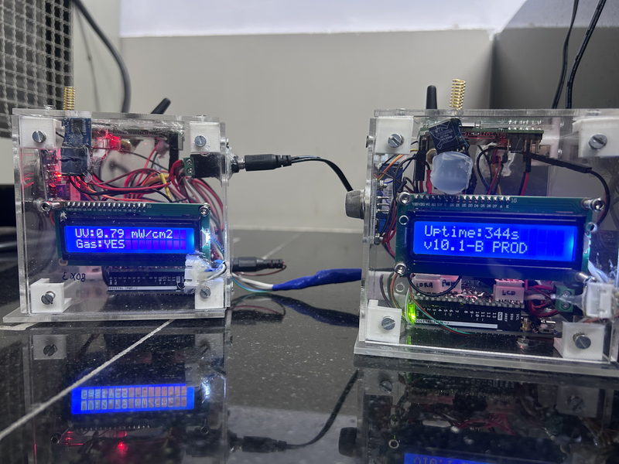
Figure 2 — Both control boxes powered and linked. Gold helical LoRa antennas, white 3D-printed corner standoffs, backlit LCD1602 displays. The left display reads UV:0.79 mW/cm2 / Gas:YES; the right reads Uptime:344s / v10.1-B PROD.
The enclosure is not a cube
Several project documents describe the enclosure as a 10 × 10 × 10 cm cube. The photographs show a box visibly wider than it is deep — a flatter rectangular form. Measure the physical unit before any patent figure is traced from the written description.

5. Communications

5.1 Channel summary
Channel | Cadence | Payload | Transport
Wi-Fi / MQTT | 5 s | Full JSON, canonical keys | Mosquitto on the Pi, port 1883
LoRa | 30 s | Abbreviated JSON, ≤240 B | RYLR998 → gateway → UART → Pi
Cellular SMS | On alert, plus every 30 min | Plain text, bidirectional | Quectel EC200U

5.2 MQTT
Topic | Direction | Purpose
sensors/zone/{id}/data | node → server | Telemetry, every 5 s
sensors/zone/{id}/alert | node → server | Threshold breach and clear
sensors/zone/{id}/status | node → server | Boot and liveness announcement
sensors/zone/{id}/control | server → node | Actuator commands
Telemetry payload:
{"node":2,"model":"Model-A","net":18,"co2":485,"temp":26.3,
"hum":52.1,"aqi":45,"pm25":12,"pm10":18,"gas":false,
"uv_mw":0.15,"fan_pwm":128,"fan_rpm":1245.0,"relay":false}
A sensor that fails to respond is transmitted as −1 rather than as zero, and the ingestion pipeline records it as an explicit offline marker. This keeps a failed particulate sensor distinguishable from genuinely clean air — a distinction that matters when the data is later used to justify a claim.
Correction to earlier documentation
Earlier project documents describe the topic structure as zone/<zone_id>/sensor_data. The firmware has always used sensors/zone/{id}/data. The code is authoritative; the earlier documents are in error.
Earlier documents also omit the fourth topic, sensors/zone/{id}/status, which the firmware publishes on boot.

5.3 LoRa
Keys are abbreviated to fit the 240-byte payload limit of the RYLR998:
{"N":2,"C":485,"T":26.3,"H":52.1,"A":45,"P25":12,
"P10":18,"UV":0.15,"FR":1245.0,"RL":false}
Key | Meaning | Key | Meaning
N | Node address | P25 | PM2.5 µg/m³
C | CO₂ ppm | P10 | PM10 µg/m³
T | Temperature °C | UV | UV irradiance mW/cm²
H | Relative humidity % | FR | Fan RPM
A | Gas index 0–500 | RL | Relay state

5.3.1 Radio parameters and network isolation
Parameter | Model A | Model B
Frequency | 915 MHz | 868 MHz (see Section 11)
Network ID | 18 | 19
Spreading factor | 9 | 9
Bandwidth index | 7 (125 kHz) | 7 (125 kHz)
Coding rate | 1 (4/5) | 1 (4/5)
Preamble | 12 | 12
Gateway address | 1 | 1
Node address | 2 | 1
A node configured on network ID 18 never receives packets from network 19; the RYLR998 filters them at the protocol layer, even when both share a frequency. This is what permits co-located deployments to operate without physical frequency separation.
This should not be oversold. Network ID separation is a documented vendor feature of the transceiver, not a contribution of this project, and it is an addressing filter rather than a security mechanism. The control path carries no message authentication, so any transmitter within radio range configured to the correct network ID can actuate the UV lamp.

5.4 SMS
The modem inbox is polled every ten seconds. Messages are read by index, parsed for sender and body, acted upon, and then deleted from modem storage so that the buffer cannot fill. Outbound messages are sent on threshold breach, on the corresponding clear, and as a periodic status summary every thirty minutes.
Command | Effect
STATUS | Immediate sensor snapshot by return SMS
HELP | Command list
STOP / START | Pause or resume the periodic updates
FAN ON / FAN OFF | Fan control
LIGHT ON / LIGHT OFF | UV lamp relay
AUTO ON / AUTO OFF | Enable or disable closed-loop mode
VERBOSE | Toggle detailed against brief message format

6. Control and Actuation

6.1 Command set
The same vocabulary is accepted on every channel — MQTT, LoRa, SMS and the USB serial console.
Command | Action | Leaves automatic mode
FAN ON | Fan PWM 255 | yes
FAN OFF | Fan PWM 0 | no — defect
F<n>, e.g. F128 | Fan PWM = n, range 0–255 | yes
LIGHT ON / RON | Relay closed, lamp energised | yes
LIGHT OFF / ROFF | Relay open | no — defect
AUTO ON | Re-enable closed loop | —
AUTO OFF | Manual control only | —

6.2 Closed-loop control law
Gas index | Lamp relay | Fan PWM
> 200 | ON | Scaled 128 → 255 across index 200 → 500
150 – 200 | Hold previous state | Hold previous state
< 150 | OFF | 0
The fan is never driven below half duty while the lamp is energised, on the reasoning that irradiating stationary air accomplishes little. The 150–200 dead band prevents relay chatter, as described in Section 3.2.3.
Operator off-commands do not currently override automatic mode
The design intent is that any manual command drops the node out of automatic mode, so that an operator override is not reverted a moment later by the control loop. Only the ON and set commands actually do this.
FAN OFF, LIGHT OFF and ROFF actuate but leave automatic mode engaged. With the gas index above the activation threshold, an operator sending LIGHT OFF sees the relay open and then close again on the next loop iteration. The command appears to have been ignored.
For a UV-C lamp this is a safety-relevant behaviour rather than a usability wrinkle. Until it is fixed, send AUTO OFF before any off-command. See Section 11.1.

6.3 Alert thresholds
Parameter | Threshold | Sensor
Temperature | > 38 °C | SCD40
CO₂ | > 1200 ppm | SCD40
Gas index | > 200 | MQ-135
PM2.5 | > 55 µg/m³ | MPM10-AS
A breach fires simultaneously on all three channels: the MQTT alert topic, a LoRa packet, and an SMS to the configured recipient. A clearing message follows on the same three channels when conditions return to normal. The alert state is latched so that a sustained breach does not generate a message on every cycle. Particulate matter is evaluated only when the reading is valid, so a failed sensor never raises a false alarm.

6.4 Dual control paths
Path | Route | Port | Appropriate when
MQTT | Grafana → Node-RED → Mosquitto → node | 1880 | Node is within Wi-Fi coverage
LoRa | Grafana → Flask → UART → gateway → radio → node | 5000 | Node is beyond Wi-Fi coverage
Both endpoints accept an identical request body. The dashboard selects between them through a template variable read from the browser URL, so a zone can be moved between transports without modifying firmware or republishing the dashboard.

7. Server Infrastructure

7.1 Services
Service |  | Container port | Host port | Role
Mosquitto |  | 1883 | 1883 | MQTT broker
Node-RED |  | 1880 | 1880 | Ingestion pipeline and MQTT control endpoint
InfluxDB 2.x |  | 8086 | 8087 | Time-series store, Flux query language
Grafana |  | 3000 | 3000 | Dashboards and operator controls
Portainer-CE |  | 9000 | 9000 | Container management
Gateway service |  | — | 5000 | LoRa ingestion and command injection (not containerised)
The 8086 / 8087 distinction causes more lost time than any other detail
Containers reach InfluxDB at http://influxdb2:8086 using the Docker network. Processes on the host, including the Python gateway service and any browser, use http://localhost:8087. Node-RED and Grafana must use the container name and the internal port; the gateway service must use localhost and the host port. Reversing them produces connection failures that resemble a dead database.

7.2 Data schema
Both transports write the same measurements and tags, differing only in a source tag. This is what allows a single dashboard to display MQTT and LoRa data together.
Measurement | Fields | Written by
co2, temperature, humidity, air_quality_index, uv_irradiance | value | both
particulate_matter | pm25, pm10, sensor_offline | both
gas_detection | detected | MQTT
fan_control | rpm, pwm_value, percentage, is_running | both
uv_light_control | is_on | both
system_status | sensors_online, total_sensors, system_health | MQTT
system_alert | alert_message, severity, alert_active | MQTT
lora_signal | rssi, snr | LoRa
Common tags are zone, node_id and source; the MQTT path adds zone_name and zone_id, and conditional tags mark particulate sensor status, fan state and lamp state.

7.3 Serial port preparation
The Raspberry Pi's PL011 UART is claimed by Bluetooth and by the serial login console by default. Until both are evicted the gateway link fails silently: the service starts, the Arduino transmits, and nothing arrives. This single step accounts for the largest share of commissioning time on a new unit, and the repository provides a script that performs it.
# /boot/firmware/config.txt
dtoverlay=disable-bt
enable_uart=1

sudo systemctl disable hciuart.service
sudo systemctl disable bluetooth.service
# remove console=serial0 / console=ttyAMA0 from cmdline.txt
sudo usermod -a -G dialout $USER
sudo reboot

7.4 Service automation
The gateway service runs as a systemd unit with Restart=always and a ten-second backoff, so it survives both crashes and reboots without operator intervention. As of version 1.2 the service takes all configuration from the environment and refuses to start if the database token, organisation or bucket is absent, rather than starting and silently discarding data.

8. Firmware

8.1 Sensor node
The node firmware uses a cooperative scheduler in a single loop, with every task expressed as an elapsed-time check. There is no real-time operating system. The design is predictable and easy to reason about, at the cost that any blocking call delays every other task — which is relevant when the cellular modem stalls.
Task | Interval | Task | Interval
Watchdog feed | 500 ms | Wi-Fi / MQTT link check | 20 s
Fan RPM sample | 1 s | LoRa publish | 30 s
MQTT publish | 5 s | Subsystem recovery sweep | 5 min
LCD screen advance | 4 s | SMS periodic status | 30 min
SMS inbox poll | 10 s
Sensor reads, the control law and alert evaluation run on every iteration. State is held in three structures covering sensor readings, subsystem health, and actuator state.

8.1.1 Recovery
Failure | Response
Wi-Fi association lost | Reconnection attempts, capped at five, then the counter resets
MQTT session lost | Up to three reconnections, followed by re-subscription to the control topic
Subsystem flagged unhealthy | A five-minute sweep re-initialises SCD4x, LoRa and the modem
Main loop stalls | Watchdog resets the microcontroller — presently disabled, see Section 11

8.2 Gateway bridge
The gateway firmware is substantially simpler: three serial ports, a parser and a forwarder. USB debug and the radio run at 115200 baud; the link to the Pi runs at 9600 because it is bit-banged in software. Receive buffers are 512 bytes on the radio side and 256 on the Pi side, both with explicit overflow handling, and only printable ASCII is admitted.
At runtime the gateway emits a heartbeat every thirty seconds and a statistics block every two minutes, counting packets in both directions along with acknowledgements and errors. It tracks a single pending command with a ten-second acknowledgement timeout — a limitation discussed in Section 11.

8.3 Gateway service
The Python service runs three concurrent responsibilities: a serial reader thread, an InfluxDB writer with reconnection logic and periodic health checks, and a Flask HTTP server providing the control API. Incoming JSON is dispatched by which keys are present, so telemetry, gateway status, heartbeats and command acknowledgements are handled distinctly and unparseable input is counted rather than fatal.

9. Multi-Zone Deployment
Each zone carries a numeric identifier that propagates through MQTT topics, database tags, dashboard variables and LoRa node addresses. Zones are grouped into models, each with its own radio network identifier and its own Raspberry Pi.
Setting | Model A | Model B
MODEL_NAME | Model-A | Model-B
LoRa network ID | 18 | 19
LoRa frequency | 915 MHz | 868 MHz
Gateway address | 1 | 1
Node address | 2 | 1
Raspberry Pi | 192.168.0.28 | 192.168.0.12
Zones served | 1, 2 | 3, 4
InfluxDB target | localhost:8087 | 192.168.0.28:8087
Model B writes into Model A's database, so a single store and a single set of dashboards cover both systems, while each Pi retains its own broker and ingestion pipeline for locally attached Wi-Fi nodes. Retargeting a gateway requires changing three constants; retargeting the gateway service requires four values in an environment file.

10. Verification and Current Status

10.1 Delivered and operational
Capability | Status
Containerised server stack with automatic start on boot | Operational
MQTT telemetry path, node to dashboard | Operational
LoRa telemetry path, node to dashboard | Operational
Bidirectional SMS alerting and control | Operational
Control via MQTT from dashboard buttons | Operational
Control via LoRa from dashboard buttons | Operational
Closed-loop automatic mode with hysteresis | Operational
Multi-zone operation with RF isolation | Operational
Automatic recovery and unattended operation | Operational
UV irradiance sensing and logging | Operational, uncalibrated
Lamp-failure detection from irradiance | Not delivered — sensor fitted, logic not written
Absolute UV dose measurement | Not delivered — requires calibration
Quantitative air quality index | Not delivered — see Section 11
Operator override of automatic mode | Partial — ON commands only

10.2 Commissioning
The repository includes a commissioning checklist covering bench safety checks before power is applied, per-subsystem verification of the node and gateway, serial port configuration, server stack validation, end-to-end data path confirmation on both transports, control tests on all five paths, alert generation on all three channels, mains and ultraviolet safety, and a resilience section requiring the system to survive a reboot and a 24-hour soak.
A unit is not considered commissioned until every item is recorded and it has returned to service unaided after a power cycle.
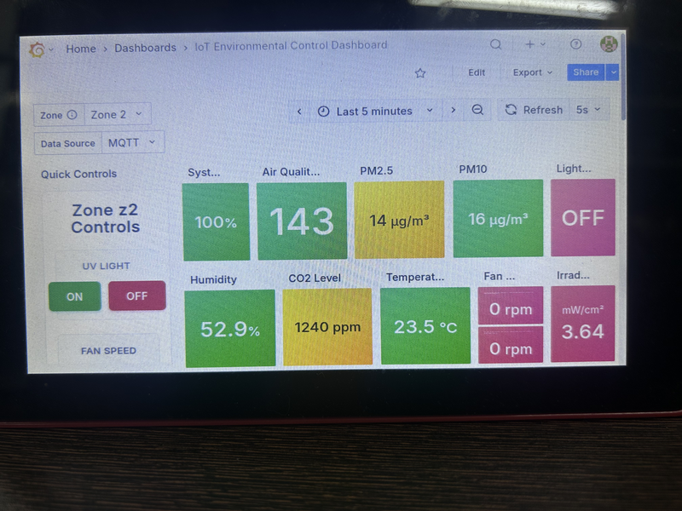
Figure 3 — Dashboard status panels, Zone 2 over MQTT. Air Quality 143 is below the 150 auto-off threshold and the lamp is correspondingly OFF, confirming the control law. CO2 at 1240 ppm is above the 1200 ppm alert threshold, so the node was in an alert state when this was captured. The irradiance panel reads 3.64 "mW/cm2" with the lamp off — a direct demonstration that the field is reporting volts.
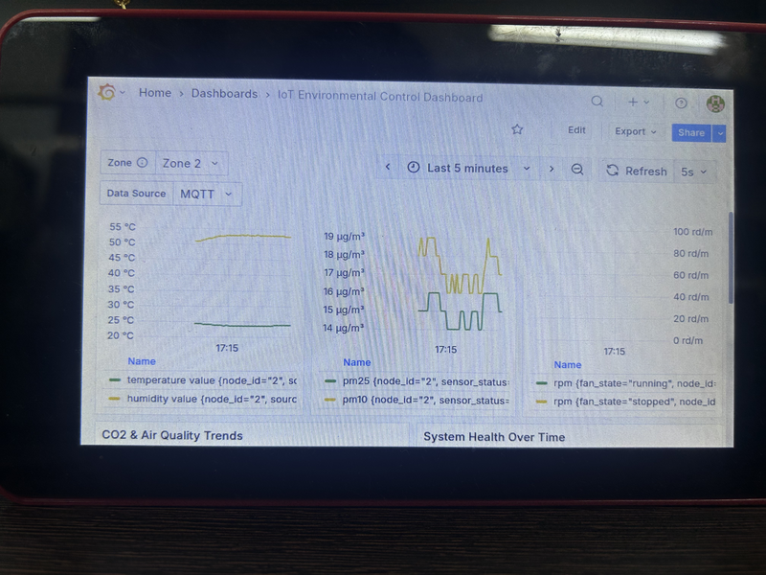
Figure 4 — Trend panels. The legends expose the stored tag structure (node_id, sensor_status, fan_state), confirming the schema in Section 7.2. Note that the left panel plots humidity and temperature against a single axis labelled in degrees Celsius — a dashboard defect, not a data defect.

10.3 Chamber context
For completeness, and drawn from the patent working record rather than from this work: two chamber geometries were built and tested. Against MS2 bacteriophage with the fan running, measured at seven minutes, the winding-path geometry achieved approximately −12 ln(C_t/C₀) against approximately −10 for the straight duct and approximately −9 for natural decay without ultraviolet. The winding path therefore outperforms the straight duct by roughly two natural-log units under matched conditions.
This result is cited here only because it explains why the instrumentation was designed around an integrated appliance rather than a standalone control box. Its methodology and validation are outside the scope of this report.

11. Known Limitations and Required Work
Every item below was verified against the source code rather than inherited from earlier documentation. None prevents the system from operating; several prevent its outputs being quoted as calibrated measurements, and one blocks deployment outside a laboratory bench.

11.1 Critical
Item | Finding | Required action
Cellular poll blocks the main loop | pollAndHandleUnreadSMS() busy-waits a fixed 5,000 ms on every call regardless of modem response, and is called every 10 s. A node with a working modem spends half its wall-clock time in that loop, ahead of sensor reads, MQTT polling, control and alerting in the same iteration. | Exit the read loop on an OK or ERROR terminator, keeping 5 s as a ceiling rather than a floor. About six lines. Fixes the RPM over-read, the publish jitter and the command latency at the same time.
Lamp-failure detection not implemented | Measured irradiance reaches the display, the serial dashboard and both payloads, and appears in neither handle_automated_control() nor check_and_send_alerts(). The control loop has one feedback input, not two. A dead lamp produces no alert and no change in behaviour. | When the relay has been closed longer than the lamp strike time, require irradiance above a floor and raise a LAMP_FAIL alert otherwise. Roughly thirty lines, and it does not require absolute calibration first. Do this before filing — it is one of the stated novelty pillars.
Off-commands do not clear automatic mode | FAN OFF, LIGHT OFF and ROFF actuate but leave automatic control engaged, so above the activation threshold the loop re-closes the relay on the next iteration and the operator command appears ignored. | Clear auto_control_enabled on the off-commands as well. Off-commands are precisely the ones where an override must stick, and the actuator is a UV-C lamp.
Credentials in version control | Wi-Fi password, personal mobile number and a read/write InfluxDB token remain in git history. The working tree has been cleaned; history has not been rewritten. | Rotate the token and change the Wi-Fi password immediately. Then decide whether to purge history or treat the values as burned.
Patent disclosure | No application has been filed. A public repository would destroy novelty. | Keep the repository private until IRCC confirms an application number.
Gas index is not an AQI | The reported value is a linear rescale of a raw ADC count. A calibration routine computes and stores a reference resistance at first boot; the measurement function ignores it entirely. | Either wire the calibration into the calculation, or rename the field to gas_index across firmware, pipeline, database and dashboards.
UV irradiance uncalibrated | The responsivity coefficient is a placeholder of 1.0, so the reported mW/cm² is a voltage relabelled. | Calibrate against a reference radiometer at fixed geometry; record both the coefficient and the geometry. Do not publish absolute dose figures until then.

11.2 Documentation and configuration
Item | Finding | Required action
LoRa band divergence | Model A operates at 915 MHz and Model B at 868 MHz, while every document and the Model B inline comment claim 915 MHz. India's delicensed sub-GHz band is 865–867 MHz, so neither value is clearly correct. | Choose the band deliberately, apply it consistently, correct the comments, and record the regulatory basis. This blocks deployment outside the laboratory.
Watchdog disabled | Both node sketches ship with the watchdog disabled, while the project report describes it as a delivered feature and the patent draft lists it as a dependent claim. It is also a timer-driven soft watchdog, not the hardware peripheral. | Re-enable it and resolve the underlying cause of spurious resets, or correct every document that describes it as active. Patent language should say "watchdog timer", not "hardware watchdog timer".
Naming inconsistencies | The database bucket appears as both UGVA Monitoring and UVGA Monitoring, and the organisation as AKunLab, AkunLab and AKunLAB, across the setup guide and scripts. These names are case-sensitive and used in four places; a mismatch fails silently. | Canonical values are organisation AKunLab and bucket UVGA Monitoring. Applied consistently throughout the new documentation.
Model B node and gateway share an address | Node B and Gateway B are both LoRa address 1 on network 19. Uplink and downlink work only by accident of that collision; the radio layer cannot distinguish the two devices, and a second Model B node cannot be added without colliding with the gateway. | Renumber before adding a second node to Model B. The documents claim Model B serves zones 3 and 4, so this will surface the moment anyone tries.
Alerting has no hysteresis | The control path uses a 150/200 dead band; the alert path uses a bare threshold comparison on the same noisy signal. A value hovering at a threshold flaps the alert, and each transition sends an SMS, which blocks the main loop for up to 15 s. | Give the alert path a dead band, a minimum re-notify interval, or both. Figure 3 catches the system 40 ppm above the CO2 threshold, well inside the flapping range.
Fan RPM bias | An earlier audit claimed the calculation never divides by elapsed time. That claim was incorrect — the sample window is gated to approximately one second. The residual issue is that the window is one second plus loop latency while the arithmetic assumes exactly one second, biasing RPM slightly high. | Optionally divide by the measured interval. Verify against a reference tachometer before quoting RPM to better than a few percent.

11.3 Robustness and security
Item | Finding | Required action
No authentication on control paths | Neither LoRa nor MQTT authenticates commands; the broker permits anonymous access and both HTTP endpoints are unauthenticated with permissive CORS. Network ID separation is addressing, not security. | Acceptable on an isolated laboratory VLAN. Before any deployment: broker authentication, bearer tokens on HTTP, and a message authentication code on LoRa command frames.
Gateway drops commands under load | The gateway tracks one pending command with a ten-second timeout. A second command issued inside that window overwrites the first, which is never acknowledged and never retried. Two rapid dashboard clicks reproduce it. | Add a short FIFO queue draining as acknowledgements arrive.
Four near-duplicate sketches | The four firmware files are approximately 1,550-line copies differing in about six constants. This duplication is the direct cause of the frequency divergence above. | Collapse to one node sketch and one gateway sketch, each with a per-model configuration header.

11.4 Recommended order of work
- Rotate the InfluxDB token and change the Wi-Fi password. Minutes of effort; currently the largest exposure.
- Decide and standardise the LoRa band. Blocks any deployment beyond the bench.
- Resolve the gas index: either make the calibration real, or rename the field honestly. Blocks publication and patent language.
- Calibrate the UV sensor against a reference radiometer. Blocks the dose-verification claim.
- Re-enable the watchdog, or correct every document that claims it is active.
- Fan RPM interval division, gateway command queue, and sketch consolidation.

12. Conclusion
The electronics and communications system described here is deployed and operational. It monitors five environmental parameters continuously, actuates a UV-C lamp and a variable-speed fan under a closed-loop rule with hysteresis, verifies lamp emission optically rather than assuming it, and delivers telemetry over three concurrent wireless channels into a local server stack that requires no internet connectivity and recovers from power loss without intervention.
Two design decisions proved load-bearing and are worth carrying into any future revision. Interposing a dedicated microcontroller between the Raspberry Pi and the LoRa radio traded architectural elegance for reliability and eliminated an entire class of timing-induced packet loss. Splitting the power supply into two isolated rails eliminated the brownout resets caused by cellular transmit bursts. Both were responses to observed failures rather than anticipatory design, and both should survive any redesign.
The system's principal limitation is not architectural but metrological. Two of its reported quantities — the gas index and ultraviolet irradiance — are repeatable relative signals presented in units that imply absolute calibration they do not possess. This is entirely adequate for the control loop, which needs only to know that conditions have worsened, and entirely inadequate for any claim quoting those numbers as measurements. Closing that gap requires a reference radiometer and a decision about what the gas channel is actually reporting; neither is difficult, and both are identified with the specific code paths involved in Section 11.
A prioritised roadmap for the work identified in Section 11 — covering credential rotation, firmware timing, sensor calibration, a redesigned control law driven by infection-risk proxies rather than a gas index, and dose-based actuation — is maintained in the repository under docs/IMPROVEMENTS.md, with drop-in reference implementations under firmware/reference/.
Alongside this report, the project repository now contains everything required to rebuild the system from components: firmware for both models of node and gateway, the ingestion pipeline, the dashboard definition, the server configuration and installation scripts, a full bill of materials with pin assignments and wiring, a phase-by-phase setup guide, an operations runbook, and a commissioning checklist. The reproducibility gaps identified in the earlier architecture review — the absent Node-RED flow and Grafana dashboard definitions — have been closed.

Appendix A. Repository Contents
Path | Contents
README.md | Master index, quick start, safety notes
ARCHITECTURE.md | System design and the reasoning behind it
docs/SETUP_GUIDE.md | Ten-phase build-to-dashboard walkthrough
docs/FIRMWARE.md | Firmware reference for node, gateway and service
docs/COMMUNICATIONS.md | MQTT, LoRa and SMS protocol reference; database schema
docs/OPERATIONS.md | Runbook, troubleshooting matrix, maintenance, security posture
docs/COMMISSIONING_CHECKLIST.md | Sign-off checklist for a new unit
docs/KNOWN_ISSUES.md | Verified defect register with fixes — single source of truth
docs/IMPROVEMENTS.md | Prioritised roadmap: security, firmware correctness, calibration, control redesign, robustness
docs/CALIBRATION.md | Per-sensor calibration procedures and record-keeping
docs/AQI_AND_UV_TRIGGERING.md | CPCB-conformant air quality sub-indices, and dose-based ultraviolet control
docs/CLOUD_THINGSPEAK.md | Cloud mirroring without introducing a cloud dependency
docs/APS_REPORT_NOTES.md | Material and suggested figures for the annual progress report
docs/figures/ | Annotated photographs of the built system
firmware/node/ | Sensor node sketches, Models A and B, with secrets templates
firmware/gateway/ | Gateway bridge sketches, Models A and B
server/ | Gateway service, requirements, environment template, systemd unit, install and serial-setup scripts
nodered/flows.json | Ingestion pipeline and MQTT control endpoint
grafana/dashboards/ | Importable 23-panel dashboard definition
grafana/panels/ | Zone control panel HTML
hardware/bom.csv | Full bill of materials
hardware/pinout.md | Pin maps, wiring, power architecture, assembly order
hardware/calibration/ | Per-unit calibration records
firmware/reference/ | Drop-in fixes for the defects in Section 11, and the proposed control redesign
nodered/functions/ | Air quality sub-index, particulate humidity correction, cloud forwarding

Appendix B. Service Endpoints
Service | URL | Purpose
InfluxDB | http://<pi>:8087 | Database administration and data exploration
Node-RED | http://<pi>:1880 | Ingestion pipeline editor
Grafana | http://<pi>:3000 | Dashboards and operator controls
Portainer | http://<pi>:9000 | Container management
Gateway API | http://<pi>:5000/health | Service health check
Gateway API | http://<pi>:5000/api/status | Statistics and per-node last-seen
Gateway API | http://<pi>:5000/api/control/zone/{id} | LoRa command injection
Node-RED API | http://<pi>:1880/api/control/zone/{id} | MQTT command injection

